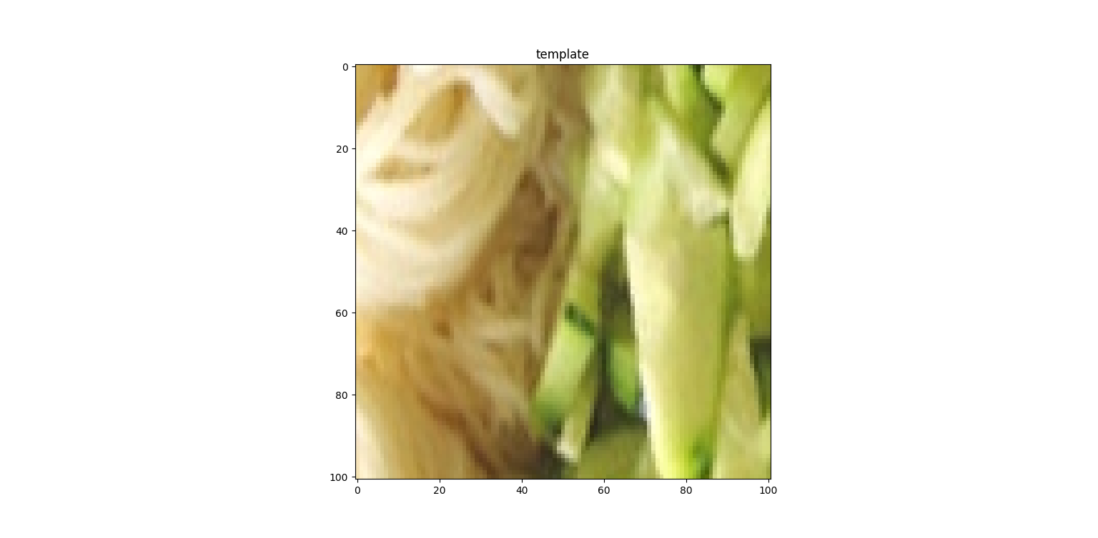Learning-Based Branch-and-Bound for Template Matching

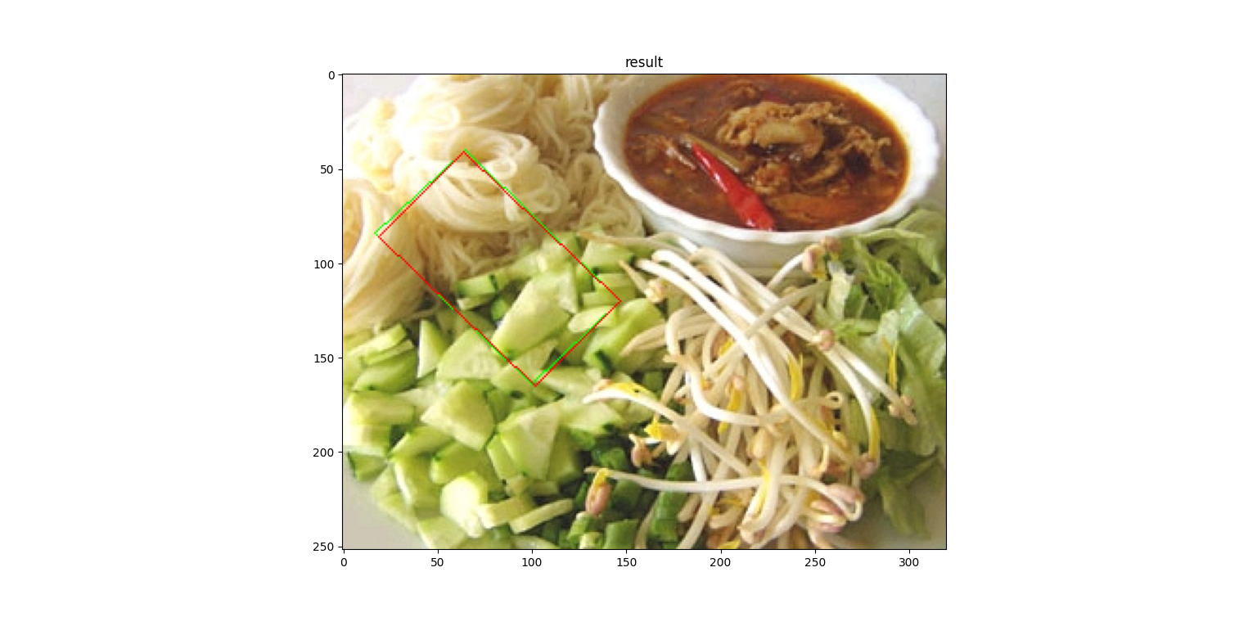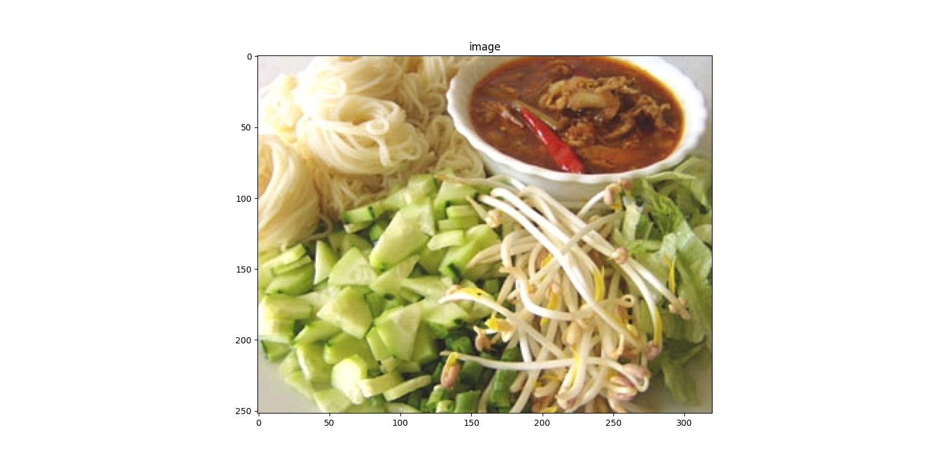

**University of Haifa,**

**Department of Computer Science**

**Etgar 14**

**August 2022**

Guided by: Dr. Simon Korman

Asaf Solomiak, 212585863, [asafucho@gmail.com](mailto:asafucho@gmail.com)

Karin Sifri, 213883903, [Karin.sifri@gmail.com](mailto:Karin.sifri@gmail.com)

Table of Contents

Problem Statement 3

Project Definition 4

Implementation 5

Installation and Features 11

Project Bottleneck 12

Our Learning 12

Future Improvement 12

# Problem Statement

Branch-and-Bound (B&B) is a general technique for accelerating brute-force in large domains. It is used when a globally optimal is desirable, while more efficient optimization methods (like gradient descent) are irrelevant (e.g., due to the minimized function being nonconvex). A particular example of interest, very common in computer vision, is that of template matching (or image alignment), where one image (the template) is searched in another. This is useful, for example, in applications like stitching of panoramas, object localization and tracking.

FAsT-Match (Fast Affine Template Matching) is an algorithm designed by Simon Korman, Daniel Reichman, Gilad Tsur and Shai Avidan ([source](https://www.cs.haifa.ac.il/~skorman/FastMatch/index.html)) to search a fixed template inside an image, using the B&B technique.

The template which the algorithm is trying to find, can be found scaled up/down, rotated and affined, therefore the number of transformations to consider is huge, and the higher bound on each sub-space of the domain is varied with respect to the current parameters and the loss function.

On each level of the algorithm, we check many transformations (also called configurations) which are spread along the search space. Each configuration is characterized by the distance between the template and the place on the image where this configuration transforms the template into, on sampled points. At the end of each level, we are left with an array of such distances, and we need to decide around which configurations to expand. Therefore, we use a threshold (the higher bound) on those distances’ values, compound of

The following figure demonstrates how B&B works in FAsT-Match:

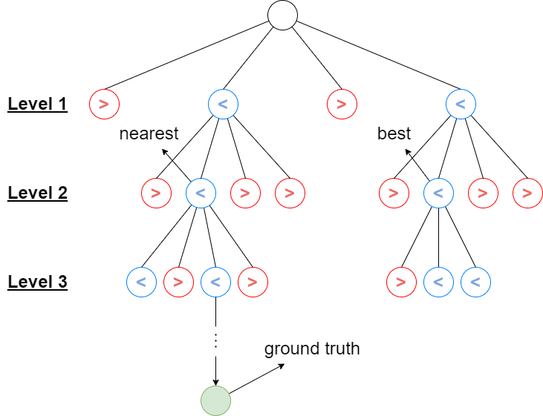

The configurations in red were not close enough to expand in the next level (), while the configurations in blue, passed the threshold and therefore were chosen to be expanded in the next level of the algorithm ()

The part of the bound is a linear combination of the delta hyper-parameter of the algorithm, which is responsible for the grid resolution of the search space, and it is lowered by the same factor each level. This linear combination has been computed manually through trial and error and it uses only one parameter – (delta), because of those reasons, it is not always optimal.

# Project Definition

To tackle this issue, we implemented the FAsT-Match algorithm in code and improved the decision process of the abovementioned higher bound by designing a Neural-Network model, resulting in time and accuracy improvement of the FAsT-Match algorithm.

In details, we modified the threshold to be

While the part is now taken from the Neural-Network model, and it isn’t only using a single parameter but a set of features (which includes delta).

The value which our model returns, ideally should be higher than the nearest configuration in the level, the one which on expansion will eventually get us to the real configuration of the template – the ground truth (green circle in the figure above).

# Implementation

First, we implemented the algorithm in the Python programming language, by translating the original code from its MATLAB version.

Afterwards, we created a data-base which we could use later for the Neural-Network creation process. We collected 100 random images from the Internet and on each image, we ran the algorithm on 100 random templates inside the image. Each level of the algorithm provided us with the following data which we collected:

* The image dimensions
* The template dimensions
* The ratio between the average pixel value in the template to the average pixel value in the image
* The template smoothness (average template derivatives)
* The template pixels’ standard deviation
* Delta – grid resolution. The one value which the higher bound in the original implementation of the FAsT-Match algorithm is computed by
* Data about the distance array of the current level’s subspace: minimum distance, average distance, distances standard deviation, percentiles (5, 10, 15, …, 95), distances range, distances amount (total number of configurations in the current sub-space).
* Affine matrix of the configuration with the minimum distance.

Total number of features collected: 37, as well as the ideal higher bound which we’ll use as the target output of the model.

In addition, on a different file we stored for each level the minimum and maximum distance values and the histogram values of the distance array divided into 100 bars. This data was collected to estimate the model’s accuracy – the percentage of the sub-space which is higher than the higher bound.

In order to ease the process of samples collection, we divided the images into 20 folders and ran the algorithm on them concurrently. We collected 73.5 KB of 68854 samples, in total computation time of 121.86 hours.

The next step was to implement a Machine Learning/Deep Learning model which on integration in the algorithm, will help us choose the optimal bound and improve the algorithm time and accuracy.

At first, we were required to do some research in those areas and learn how to implement such thing and what is the best model for our problem. Lastly, we chose to use Multi-Layer Perceptron for Regression model, which is a simple Neural-Network consisting of some fully-connected linear layers.

Additionally, we have decided to use only 10 out of the 37 features which we collected on our samples, because after the collection process, we noticed that many features were highly correlated or not necessary for our model. The 10 features used:

* The template dimensions
* The ratio between the average pixel value in the template to the average pixel value in the image
* The template smoothness (average template derivatives)
* The template pixels’ standard deviation
* Delta – grid resolution. The one value which the higher bound in the original implementation of the FAsT-Match algorithm is computed by
* Data about the distance array of the current level’s subspace: minimum distance, average distance, distances standard deviation, distances range, distances amount (total number of configurations in the current sub-space).

The process of choosing the right model’s parameters was conducted mainly by trial and error, and estimating the model performance by the following values:

* Loss – we used MSE (squared distance between the target and the model’s prediction) as our model Loss-Function.
* Score – the ratio between our loss to the loss we would have got if we were predicting the average target value every time.
* Accuracy – percentage of times we succeeded on passing the ground-truth configuration to the next level in the algorithm ().

Example:

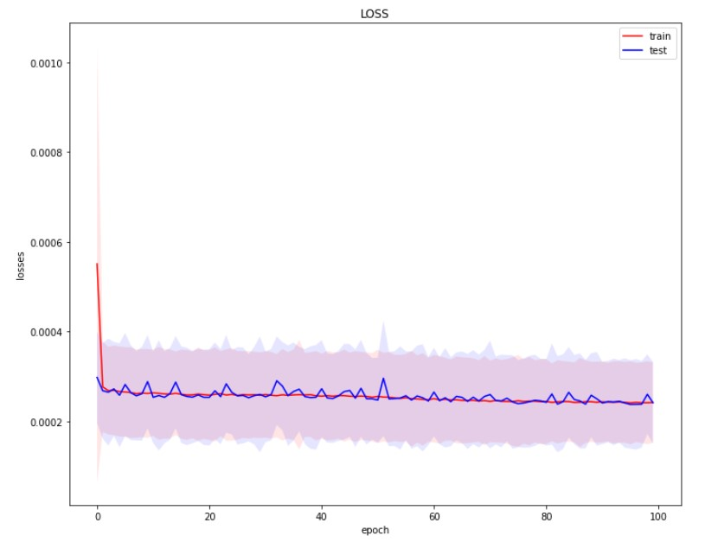Loss per epoch graph:

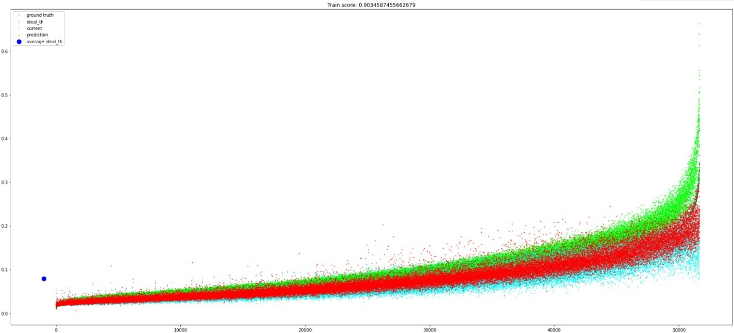Model predictions on training-set graph:

* Green – target
* Red – prediction
* Lime – ground-truth
* Cyan – the current higher bound (without a model)

Metrics on the test-set:

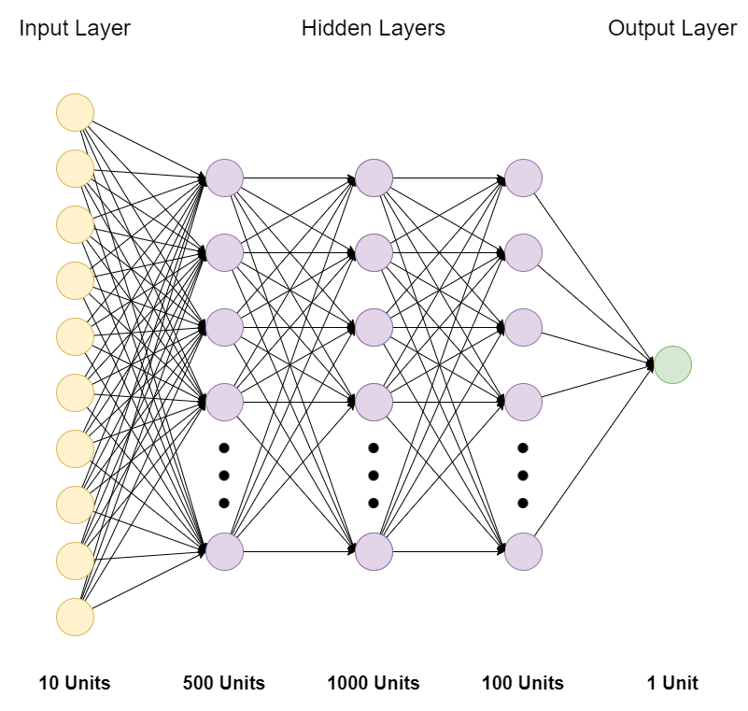After many trials, we came into our final model configuration:

And the following hyper-parameters:

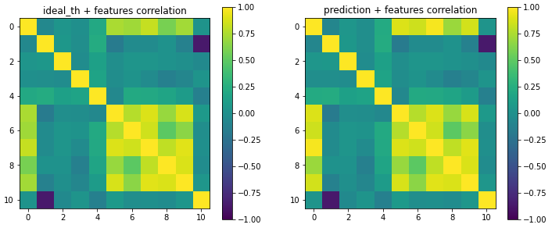Feature correlation image, plus the target value (in the 0th row and column):

The last step of the project was to check whether integrating this model in the FAsT-Match algorithm can improve its speed and accuracy results.

We ran on various target values to compare the results of each of them to the version of the algorithm without any such model.

The target value that was used is:

Every time, we checked on a different set of factor values and continued to search around factor values which gave us good results. We compared the speed results by the average time per run, and the accuracy results by the Jaccard Index as well as the average distance between the corners of the found template to the ground truth one.

On the final round, we measured the results of 15 models with factor in the range 0.15-0.6 and got the following results on 400 test runs:

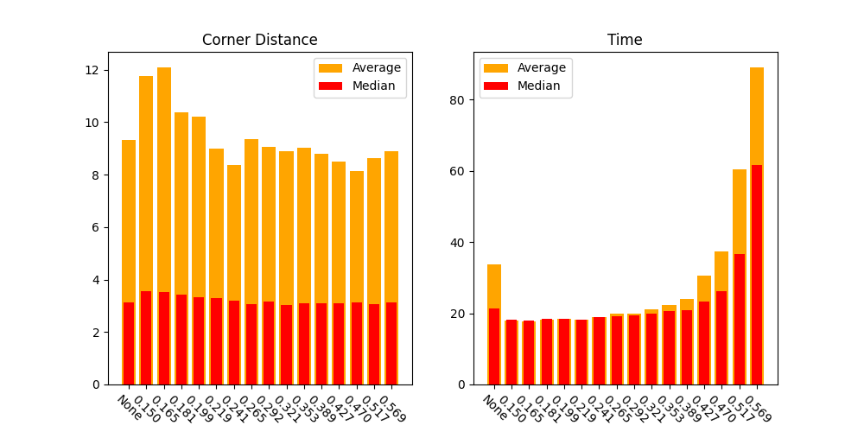

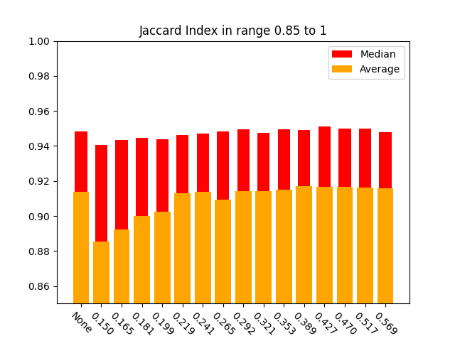

We can clearly notice the trade-off between accuracy and time. For instance, models with factor in range 1.5 to 2.1 got corner distance values higher and Jaccard index values lower than the rest of the models, while models with higher factor values got good accuracy results but it took them more seconds to complete a run.

We can also notice by comparing to the first bar, that our models can barely improve the accuracy, but they can improve the speed of the algorithm, mainly the worst cases as indicated by the average value of the bar in the Time graph. This worst-case improvement is demonstrated in the following graph which shows the time results on 400 runs (on each model), sorted by the time values got on the runs without any model (in black):

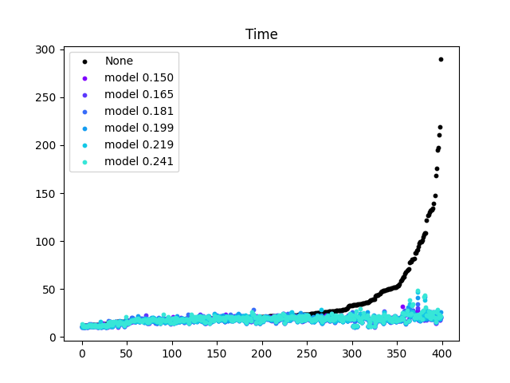

We could use this trade-off to integrate the desired model according to the purpose of our usage in the algorithm, but if we would have need to choose one model which works good generally, we would integrate the model with the factor 0.241 for its good speed results and slight accuracy improvement.

This improvement shows that the use of such model in the FAsT-Match algorithm increases its stability in terms of speed, while keeping the same quality of results.

# Installation and Features

Our entire project, including the 2 original versions are available in [Github](https://github.com/Asaf21S/Final-Project). Our work and improvement of the algorithm can be run from PyCharm by running the main file and uncommenting the parts of the project which you want to activate:

* Run the FAsT-Match algorithm on a given or random template, without any model.
* Collect samples in csv files.
* Display how our choice of features affects the ideal threshold.
* Show graphs of speed, corners distance and Jaccard Index results, on various factor values.
* Run the algorithm on a random template and choose MLP model to include.

On each FAsT-Match run, a different set of hyper-parameters can be configured. Such parameters define the algorithm’s search space, the number of points sampled in the template to estimate each configuration’s accuracy, and whether to use photo-metric invariance (useful in case the template isn’t artificially created).

In order to run the code, ones need to download the following packages:

* NumPy
* Matplotlib
* OpenCV
* scikit-learn
* pandas
* PyTorch

# Project Bottleneck

In our opinion, the difficult part of the project was to implement the algorithm in Python. At first, we tried to translate it from its C++ version but with no success. Then, we passed to the MATLAB version, and even after we finally managed to translate the algorithm and checked that it worked, our implementation took significantly longer than what it took in MATLAB.

We had to search and try many things to attempt to fix it. At the end, to shorten the amount of time on ‘for’ loops we used Vectorized Operations. On situations where we couldn’t optimize the loop in this way, we divided it into smaller loops and decreased the use of memory in those loops, eventually shorten the time for these loops due to less memory-paging.

# Our Learning

At the beginning, we didn’t understand much about the algorithm and how could we improve it, so we had to do some research on these fields beforehand.

We learned how to read and understand the MATLAB programming language. Because the entire project was written in Python, though we both had some experience with it, we learned and improved our skill-set as well as understood how to optimize our code in this language.

Furthermore, we learned a lot about the Deep Learning field and how to find and train the correct Neural-Network for our problem.

# Future Improvement

There are some directions which we thought of to do more progress.

We could think of a different Machine Learning or Deep Learning model with different target and parameters’ values. We could also use a similar model to predict different parameters in the algorithm or a more general predictions that will replace more major parts of the algorithm.

In addition, potential research could be to find out how different features of the image and template can affect the outcome of the FAsT-Match algorithm in terms of speed and accuracy. Those features may include the smoothness of an input image or using a natural template versus an artificially created one.